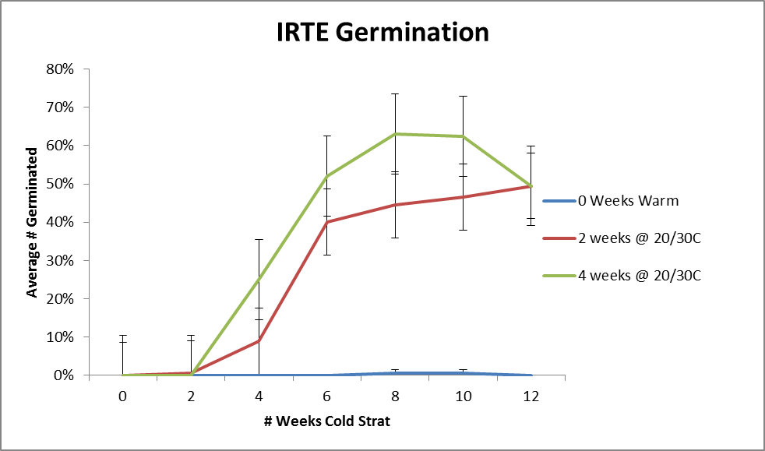Germination protocol evaluation for *Iris tenax*

Katie Jones and Tom Kaye

Institute for Applied Ecology

Preliminary results

Sept. 2010

Optimal germination was obtained after 4weeks warm (alternating 20-30°C) stratification followed by 8 weeks of cold (5°C) stratification. Seeds were then moved back to warm conditions for germination. TZ tests resulted in an estimate of 77% PLS for the seed lot used in this experiment.